EXP NO 5:
CREATE A SIMPLE CLOUD SOFTWARE APPLICATION FOR LIBRARY BOOK RESERVATION SYSTEM FOR SIMATS LIBRARY USING ANY CLOUD SERVICE PROVIDER TO DEMONSTRATE SAAS

AIM: To Create a simple cloud software application for Library book reservation system for SIMATS library using any Cloud Service Provider to demonstrate SaaS
procedure:
step1: go to zoho.com
step 2: login to the zoho.com
step 3: select one application
step 4: enter application name
step 5: created new application
step 6: select one form
step 7: the software has been created.
Output
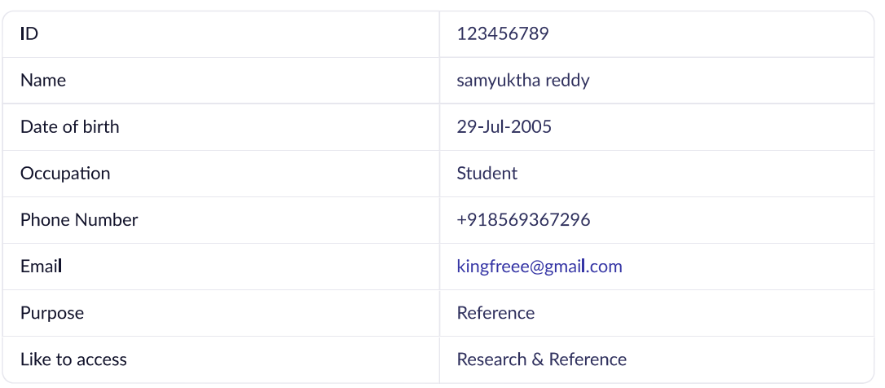

RESULT:
Successfully created a simple cloud software application for Library book reservation system using any cloud service provider to demonstrate SaaS

